**Report #1:**

* Find out if the supplier are delivering on time and what is the gap between expected and actual delivery dates

**Description of Report:**

* This report gives a monthly summary showing the expected and actual delivery dates for each supplier also while highlighting any delays

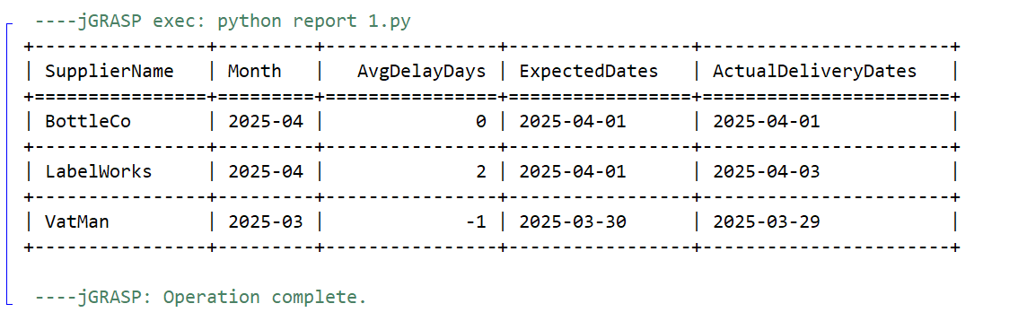

**Report #2:**

* Analyzes wine sales by the different types and shows which wines are underperforming while also keeping track of which distributor is responsible for each wine

**Description of Report:**

* This report shows total bottles sold per wine type and tracks wines to their corresponding distributors

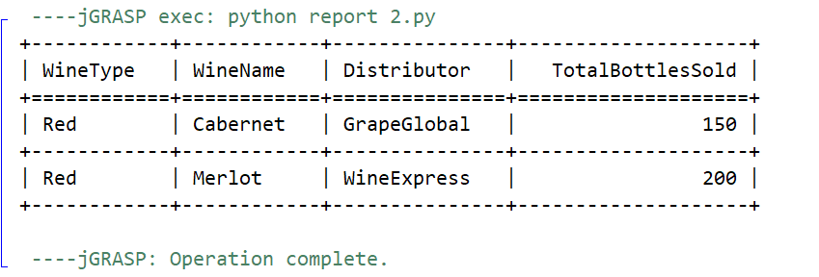

**Report #3:**

* Summarizes employee labor data over the past four quarters

**Description of Report:**

* A quarterly summary of total hours worked by each employee

